Unmasked Website Text

Download Page

-Change “dartmouth unmasked” to “unmasked project”

-description below title: an anonymous, mental health social media mobile application for Dartmouth students

-insert apple app store download icon link

About Us Page

Unmasked Project is an anonymous, mental health social media mobile application for Dartmouth students, by Dartmouth students. On the app, students can take off their masks and share what’s really going. Trained students will moderate the community forum. This app would not have been possible without the support of our sponsors: the Dartmouth Digital Applied Learning and Innovation Lab (DALI), the Magnuson Center for Entrepreneurship, the Dartmouth Investment & Philanthropy Program (DIPP), and Alpha Theta.

Team Page

Sanat Mohapatra ’20 Founder



John Schlachtenhaufen ‘20

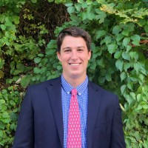

Joe Hall ‘20



Teddy Hill-Weld ‘20



Jon Song ‘20

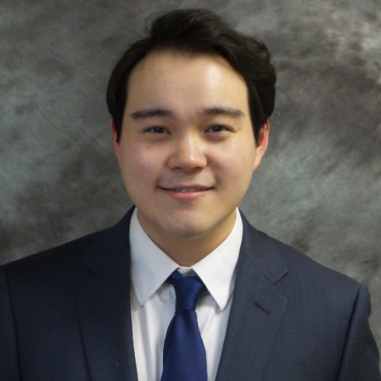

Syed Tanveer ‘21

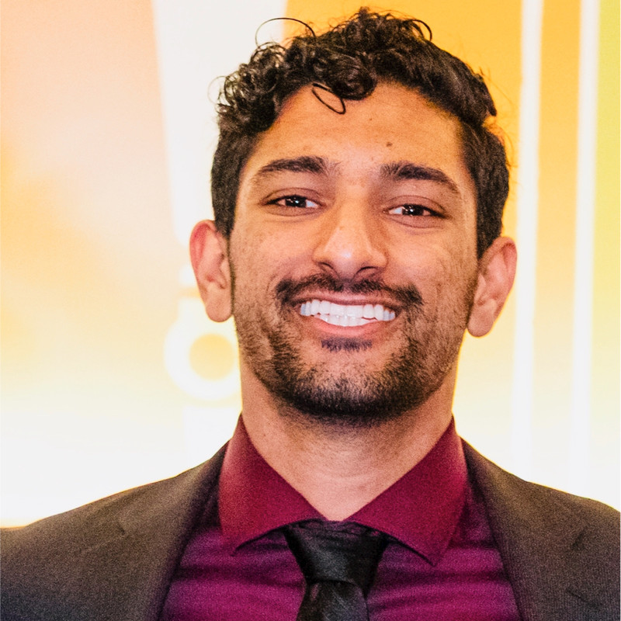

Jenna Salvay ‘20



Soohwan Park ‘19



FAQ Page

1. Is it really anonymous?

Yes! The app is completely anonymous with one exception. ONLY in the event of serious perceived threats to self or others will we provide local law enforcement with access to personally identifiable information. No one directly associated with the app will have access to user data. All user data is encrypted.

1. Is it safe?

Yes! We have a team of Unmasked moderators, who have gone through Dick’s House-certified mental health peer support training, that will regularly review content on the app. Please use flagging and direct message reporting features if you ever run into malicious content.

1. When will it be available on Android?

We will begin Android development after we see the results of our iOS launch.

1. How do I contact the Unmasked team?

If you have any questions, concerns, or are interested in joining our team, please contact us at help@unmaskedproject.com.

1. How do I submit app feedback?

Please submit feedback here: <https://forms.gle/DLyqVp7iTSnrhVDT8>.

Resources Page

I imagine this could work through entries that expand.

Table of Contents:

Free, Confidential 24/7 Emergency Hotlines

Issue-Specific Free, Confidential 24/7 Emergency Hotlines

WISE

National Suicide Prevention Lifeline

Rape, Abuse, Incest National Network (RAINN)

National Domestic Violence Hotline

National Dating Abuse Helpline

Substance Abuse and Mental Health Services Administration

The National Eating Disorders Association

Trevor Project (LGBTQ)

Free, Confidential 24/7 Emergency Hotlines:

Emergency Services: 911

Counselor-on-Call (S&S Dispatch): 603-646-3333

Safety and Security 24-hours a day: 603-646-3333

Dean-on-Call (S&S Dispatch): 603-646-3333

Counselor on Call (Non-S&S Dispatch): 603-646-9440 (fall, winter, spring) / (603) 646-4000 (summer, breaks, holidays)

Dick’s House Inpatient Department (IPD): (603) 646-9440

Hanover Police non-emergency: 603-643-2222

Dartmouth Hitchcock Emergency Room: 603-650-7000

Issue-Specific Free, Confidential 24/7 Emergency Hotlines

Upper Valley WISE: 866-348-WISE (http://www.wiseuv.org/)

WISE is available 24/7 for both crisis management/mental health support as well as providing further information about options after someone has experienced harm. WISE is a confidential resource, with trained consultants who are particularly apt at designing escape plans for those that are seeking a safe way to leave an abusive relationship. Should you request one, WISE representatives are also available to accompany you to appointments regarding harm that may be stressful, such as courtrooms, meet the Hanover Police, etc. WISE has both self-identifying men and self-identifying women to speak to, and you can request whomever you feel comfortable speaking with.

National Suicide Prevention Lifeline: 800-273-8255 (www.suicidepreventionlifeline.org/)

The National Suicide Prevention Lifeline is a national network of local crisis centers that provides free and confidential emotional support to people in suicidal crisis or emotional distress 24 hours a day, 7 days a week. They’re committed to improving crisis services and advancing suicide prevention by empowering individuals, advancing professional best practices, and building awareness.

Rape, Abuse, Incest National Network (RAINN) Hotline: 800-656-HOPE (4673) (www.centers.rainn.org/)

Use this tool to find help near you. This list is made up of independent sexual assault service providers, including National Sexual Assault Hotline affiliate organizations and other local providers. Staff at these programs are dedicated to helping survivors in your area.

National Domestic Violence Hotline: 800-799-7233 (www.thehotline.org)

Their highly-trained advocates are available 24/7/365 to talk confidentially with anyone experiencing domestic violence, seeking resources or information, or questioning unhealthy aspects of their relationship.

National Dating Abuse Helpline (loveisrespect.org) Call: 866-331-9474 or Text: LOVEIS to 22522

Their trained peer advocates are available 24/7/365 to offer education, support and advocacy to teens and young adults, as well as their concerned friends and family members, who have questions or concerns about their dating relationships. They also provide information about dating abuse to service providers, counselors, teachers and members of law enforcement.

Substance Abuse and Mental Health Services Administration (SAMHSA): 800-662-HELP (4357) (www.samhsa.gov/find-help/national-helpline)

SAMHSA's National Helpline is a free, confidential, 24/7, 365-day-a-year treatment referral and information service (in English and Spanish) for individuals and families facing mental and/or substance use disorders.

The National Eating Disorders Association: 1(800) 931-2237 (https://www.nationaleatingdisorders.org/help-support/contact-helpline)

The NEDA Helpline is available Monday-Thursday from 9AM to 9PM ET, and Friday from 9AM to 5PM ET. Contact the Helpline for support, resources and treatment options for yourself or a loved one. For crisis situations, text "NEDA" to 741741 to be connected with a trained volunteer at Crisis Text Line.

Trevor Project (LGBTQ): (866) 488-7386 (https://www.thetrevorproject.org/#sm.000zez93m1qjdzv11bq295wrx3y03)

A national 24-hour, toll free confidential suicide hotline for LGBTQ youth.